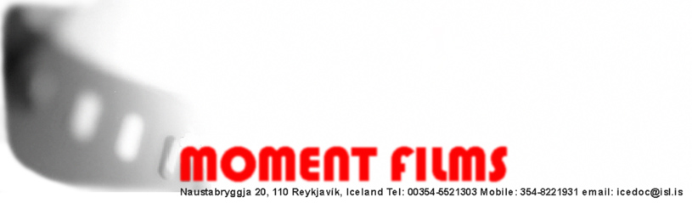

Kári G. Schram
producer, director, writer

Curriculum Vitae

KVIKMYNDAGERÐIN ANDRÁ EHF aka MOMENT FILMS: Naustabryggja 20, 110 Reykjavík, Iceland
Tel: 354-5521303 Mobile: 354-8221931 email: icedoc@isl.is, kt:230860-5649

Priors: Business degree, Agricultural degree, Photography degree, Graduated from
San Francisco Art Institute, B. F. A. Filmmaking.

Kári founded and established Andrá/Moment Films in 1989. Which has been involved with all aspects of Icelandic film making. During the 20 years Kári has been one of Iceland’s leaders
of creative documentaries and television production. He works as director, producer and writer. Moment Films is a member of the Association of Icelandic Film Producers.

1994 „ Coronation Day“
Nominated DV cultural prize best Documentary.
About the controversial bohemian street poet Dagur Sigurðarson. Chosen for the Focus on Nordic countries - International Documentary Film Festival Amsterdam.

1995„25 Undocumented“
A program series of 10 x 25 min. individual programs about offbeat characters living and thriving by there own rules and in there own way in modern Iceland. The series got critical and public acclaim.

1996„ The Icelandic Experience story of a Nation.“
52 min. Documentary portraying the cultural and social history of Icelandic from the first settler to the present day. Selected for the retrospect of Nordic films in National museum of national Art, Paris.

1997"Concrete Dreams"
52 min. Docudrama about Samúel Jónsson a hermit farmer living on the outskirts of Iceland that kept silently a dream about a fanciful world of art situated between dream and reality in his hart for decades. It was not until he got his old age pension that he got the opportunity to make his dream come true. Selected for screening at the Pompidou Museum, Paris.

1999‘’XXXREYRI’’
A Mocumentary on the sex revolution taking place in Iceland during the early 21 century. Strip clubs and lap dancing have never been introduced to the Icelandic common man and woman and the program takes an offbeat look at this new favorite pastime of Icelandic society.

1999„The secrets lives of Icelandic sea and water Monsters “
52 min. A creative documentary that portrays the search for the hidden existing sea and water monsters of Iceland. The documentary deals with stories told by living contemporary witnesses and from written accounts of Iceland’s most notable and feared monsters. An odyssey through the wild and spectacular Iceland, exploring for the existence of Iceland’s best kept secret.

2002„The First Voyage“
super 16 mm 52 min.Docudrama on the Viking discovery of North America around the year 1000 AD, and the remarkable men and women who experienced that great adventure. Narrated by Magnús Magnússon (BBC) and features the leading authorities on this historical period. They shed a new light on this forgotten historical truth about the Icelandic Vikings on the shores of America 500 years before Columbus. Chosen for the Smithsonian institute film screenings and the national library of Congress screenings on the 1000 years anniversary of the Icelandic discovery of the America.

2001’’Wilde Thing’s’’
2 x 25 min. A program series on the natural
environment’s gift to Icelandic culinary fauna. Lead by Iceland’s most progressive self mad chef. Rúnar brings us to understand the abundant food chest that we can gourmet our self’s from our surrounding nature. Got critical and public acclaim.
A series that will make your mouth water.

2006‘’Wild West fjords’’
2x35 min. television programs Nominated for the Icelandic National TV and film awards for best television program. About the people living in the West fjords of Iceland telling their, story, dreams, hopes and culinary secrets. Inn spectacular geological surroundings that has molded them in a unique way.

2008 Rumenatomija - the story of Brandas addiction
A short documentary.
Branda is a wonderful cow but she is in a terrible state now she is addicted to all things made of plastic. She is so far sunk in her addiction that if she dose not get help soon she will explode and die. In these times of super plastic pollution she is facing an awful dilemma and can’t cut her habit. She is in need of serious help. This is the story of Branda the cow at a critical time in her life.
Film Festivals official selection:
Nordic Panorama 5 city festival, Hot Docs Toronto Canada, Go short Netherlands, RIDM - Rencontres internationales du documentaire de Montréal Montreal

2011 Blikkið the story of Melavöllur
2 x 45 min documentary about the national arena from 1910 to 1987. This is where Iceland rose highest in it’s history of sports and there common fight for independence and freedom.

2011 Mr.ICELAND the story Þórður from Dagverðará
52 min a documentary about Thordur Haldórsson Mr. Iceland one of Icelands most interesting and prolific man.

beside being the assistant producer on the Oscar Nominated film ’’Children of Nature’’

